Project Development – Delivery plan sprint-3

| Date | 11-Nov-2022 |
| --- | --- |
| Team ID | PNT2022TMID33886 |
| Batch | B8-2A4E |
| Project Name | Project - IoT based Safety Gadget for Child Safety Monitoring Notification |

**Creating and Integrating Node-Red with Web UI**

**Creating Cloudant DB:**

**Step1:**Go to the existing created node red and click the launch dashboard.

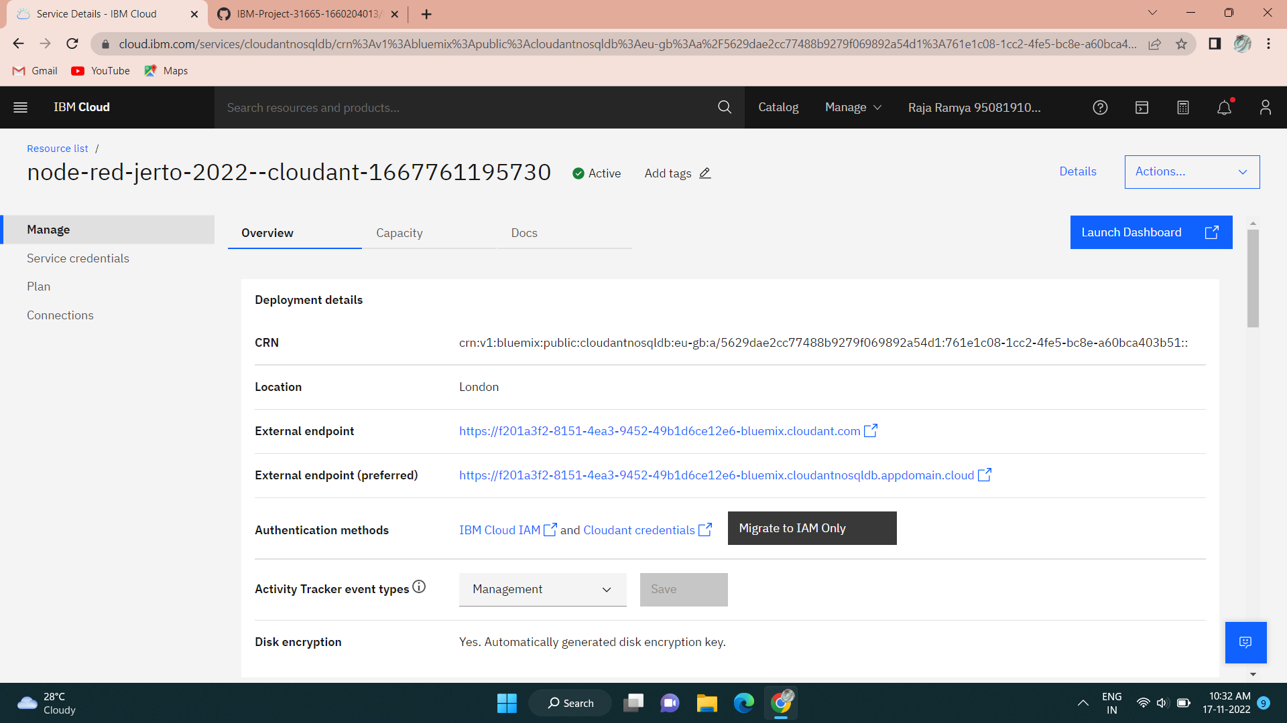

**Step2:**Database window opens.

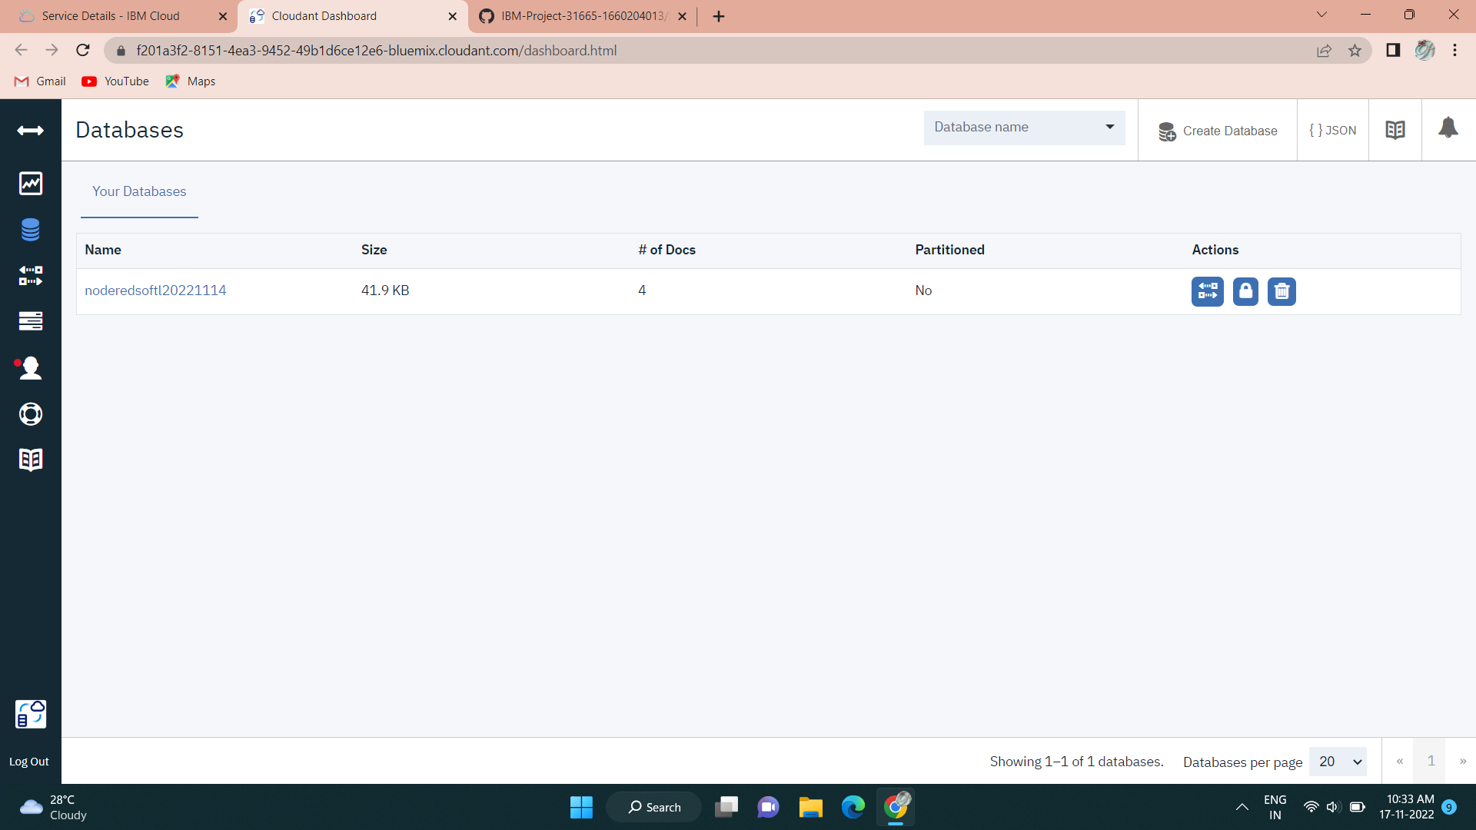

**Step3:**Click create database option on top right side and enter the database name and select non partitioning option.

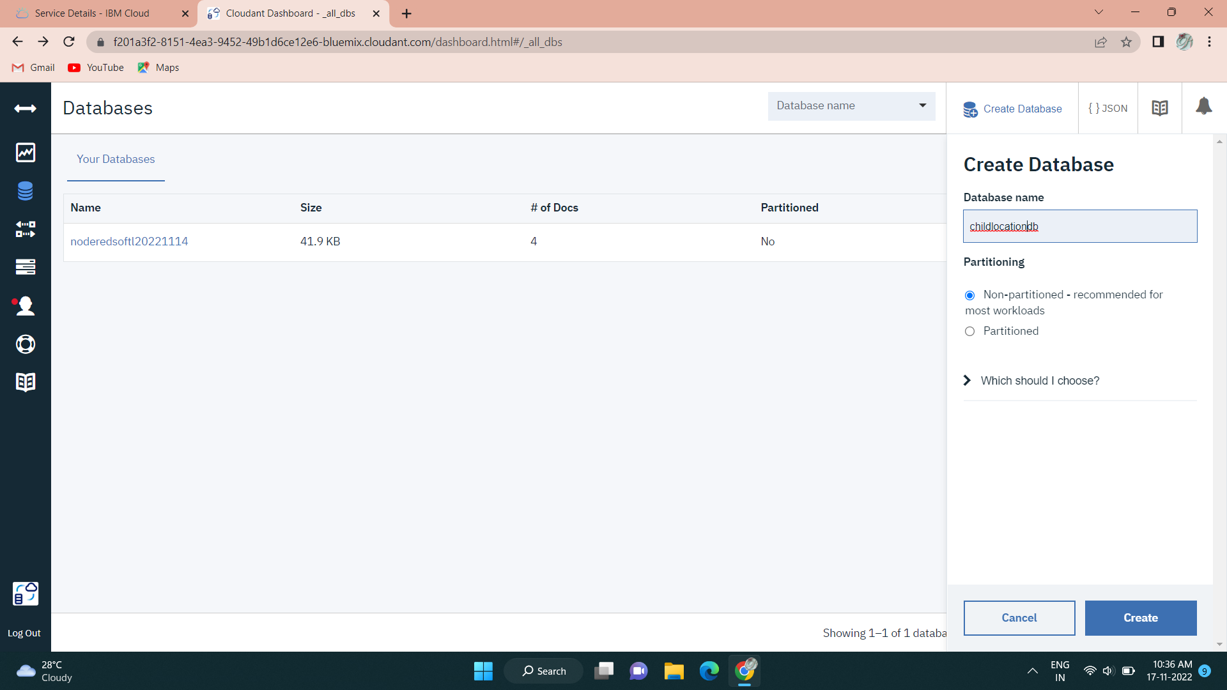

**Step4:**Click on create document option.

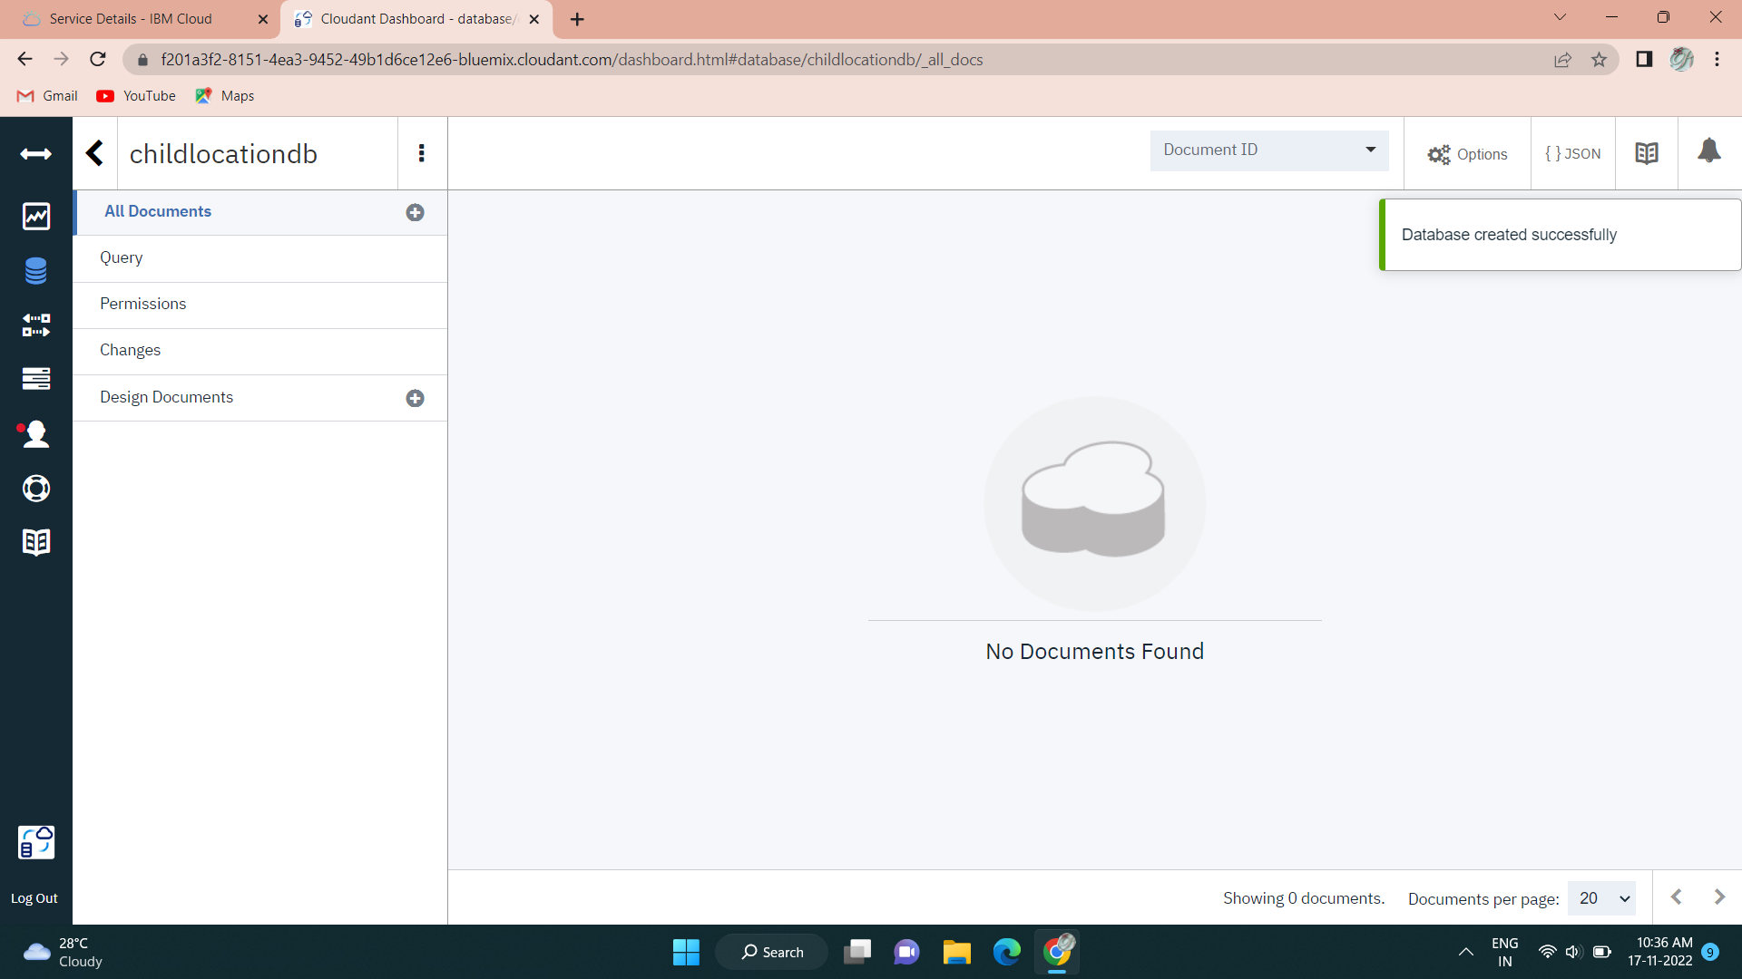

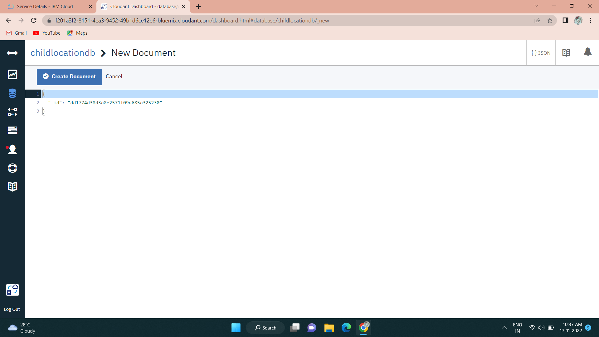

**Step5:**The document was saved successfully with the credentials.

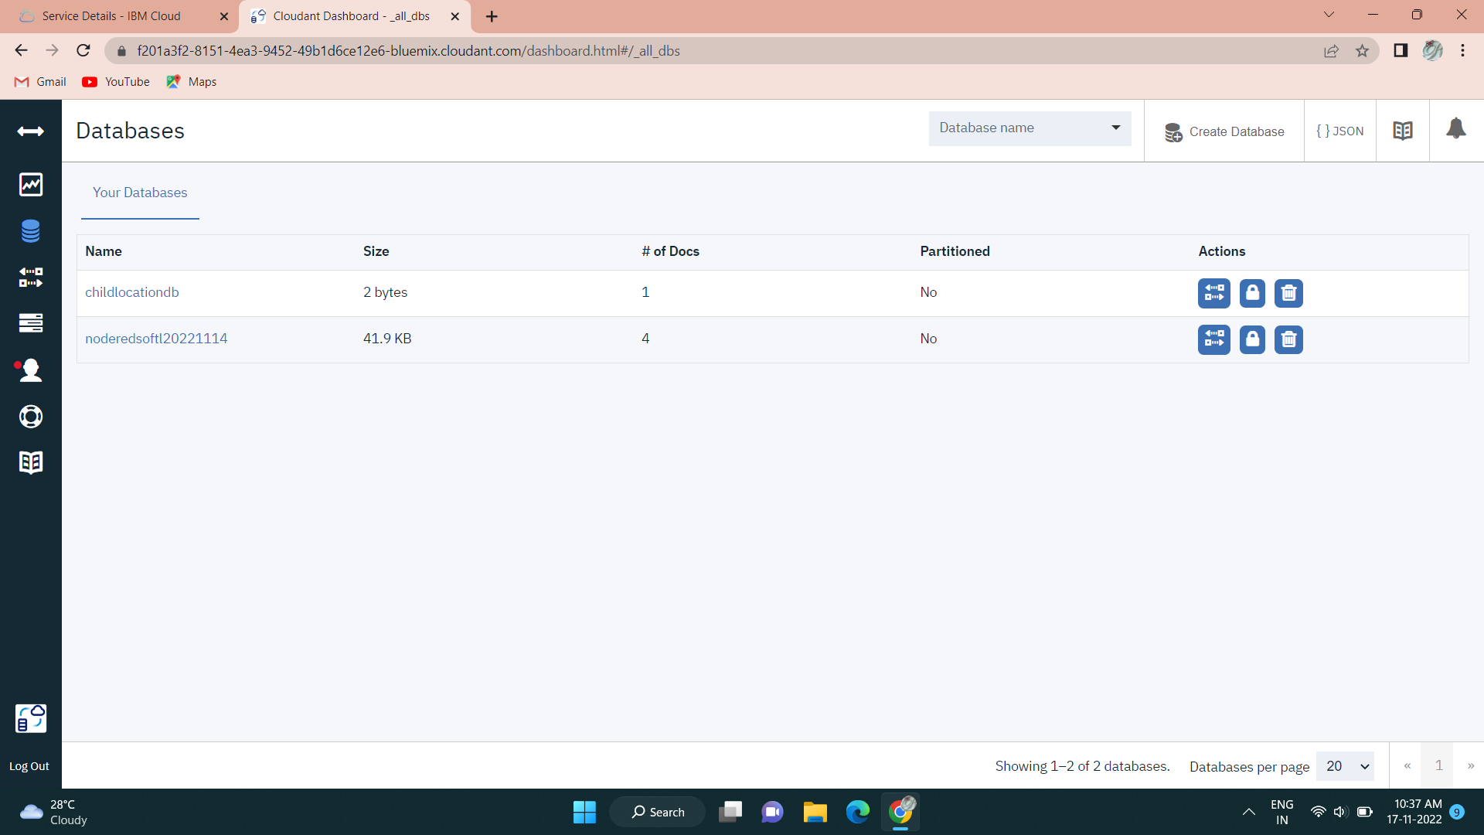

**Node-Red Service with Cloudant Database:**

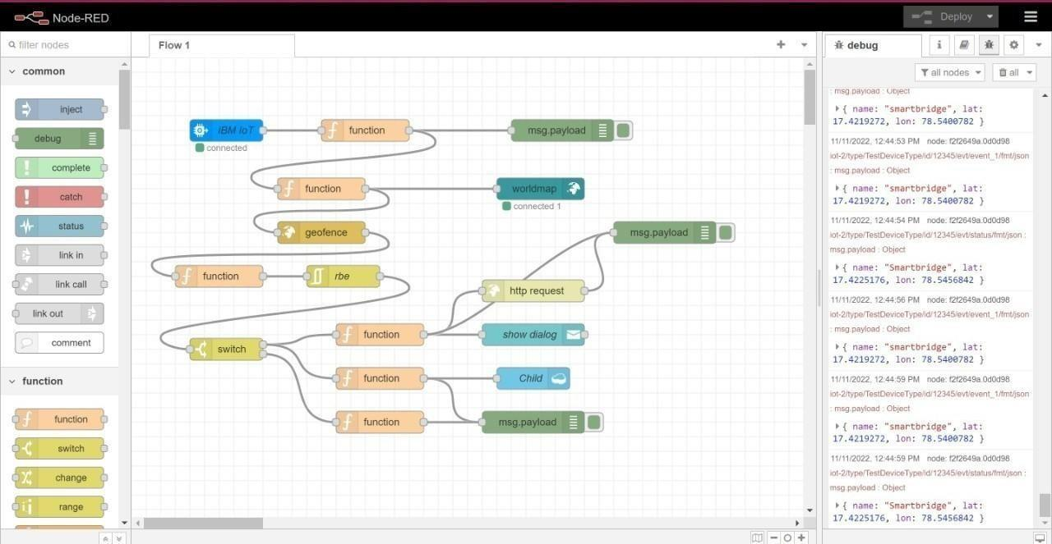

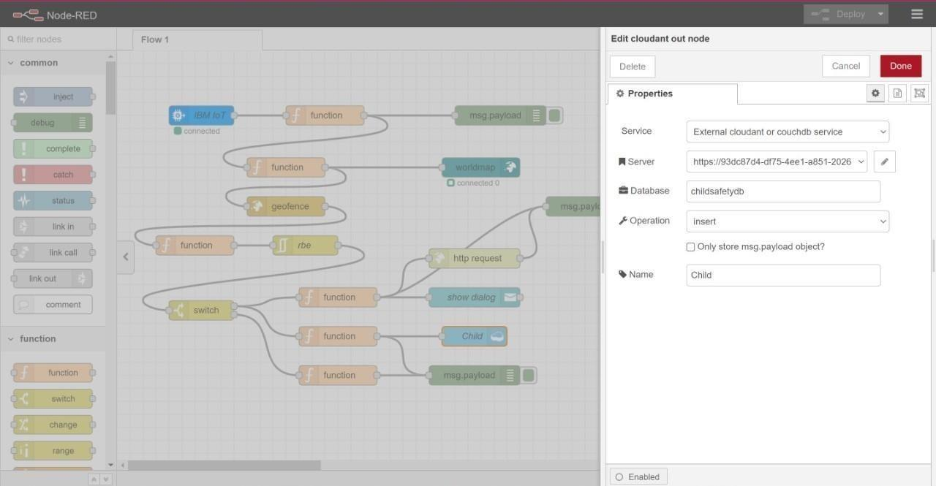

**Node-Red Dashboard(Web ui):**

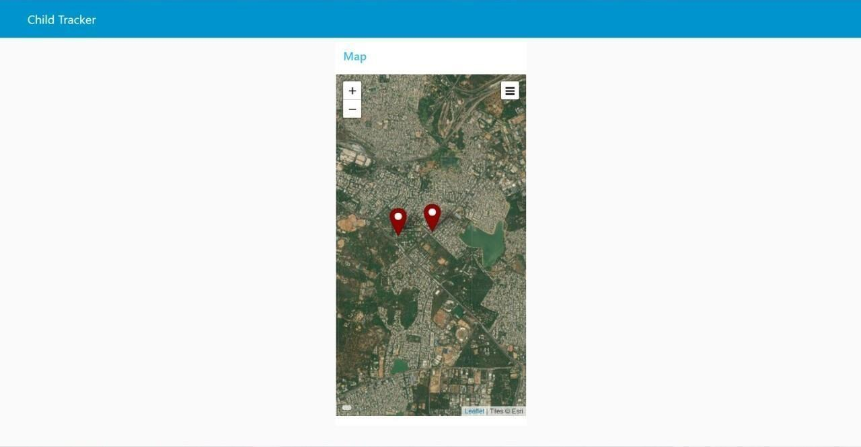

**thus Created, Integrated Node-Red with Web UI**